Renowned Corvette Expert Noland Adams Passes Away at the Age of 84
corvetteblogger.com Jan 21, 2017
One of the Corvette world's best known experts has died at age 84.
Noland Adams was a frequent contributor to many Corvette publications for many years and used his first-hand knowledge to write the "bibles" of Corvette restoration - Corvette Restoration & Technical Guide, Volume I, 1953-62, and Corvette Restoration & Technical Guide, Volume II, 1963-67.
He also wrote "Corvette, American Legend," covering the original dream car prototype and 1953 production, and the follow-up series, "1954 and 1955 Production," "1956 Production," "1957 Racing and Production details," and "1958 to 1960 Variations."
Adams also hosted a series of restoration videotapes, wrote hundreds of articles about Corvettes, and gave countless presentations on Corvette restoration all over the United States, plus seminars in Canada, Sweden, and England.
Adams also was a consultant to the model car industry, serving as technical advisor on Monogram's 1953 Corvette model car kit and Franklin Mint's 1953 Corvette model. His personal 1953 Corvette was used to design the 1953 Corvette stamp offered by the US Postal Service in 2005.
He was known around the world for his knowledge of Corvette development heritage and technical understanding and was a longtime member of the National Corvette Restorers Society. He was a common sight at Corvette shows and functions year after year where he gladly shared his Corvette expertise and knowledge with Corvette enthusiasts everywhere.

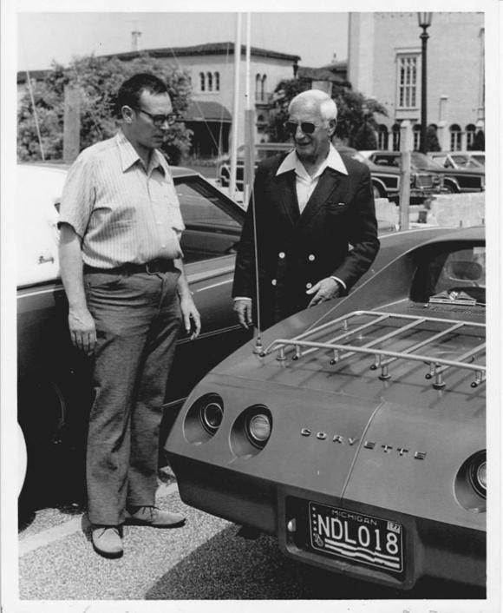

Noland Adams (L) with Corvette Chief Engineer Zora Arkus-Duntov (R)
Adams was also the Founding President of the Solid Axle Corvette Club and over the years, had amassed an impressive collection of old Corvette documentation from Chevrolet.
After a lifetime devoted to America's Sports Car, Adams was inducted into the National Corvette Museum Hall of Fame in 2003.
The Corvette world definitely owes Mr. Adams a debt of gratitude for his enthusiasm and willingness to share his knowledge about "our car."
Funeral services will be held Friday, Jan. 27th at the LDS Church, 1275 Green Valley Rd., El Dorado Hills, CA. Viewing at 11:00 am. Service will follow at 12:00 pm.
Click to read the full story

